Quiz

Top of Form

**Question 1**(1 point)

*Saved*

Workbooks are represented as a.XLSX file

Question 1 options:

|  |  |
| --- | --- |
|  | True |
|  | False |

**Question 2**(1 point)

*Saved*

Study the screenshot on below.  Which of the following options represent the actual contents of the selected cell (D4)?

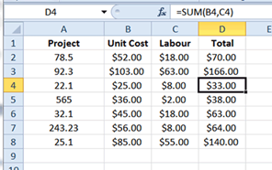

Question 2 options:

|  |  |
| --- | --- |
|  | The contents of D4 is =SUM(B4,C4). |
|  | The contents of D4 is $166.00. |
|  | The contents of D4 is $33.00. |
|  | The contents of D4 is D4. |

**Question 3**(1 point)

*Saved*

Which area in an excel window allows entering values and formulas

Question 3 options:

|  |  |
| --- | --- |
|  | Title bar |
|  | Menu bar |
|  | Formula bar |
|  | Standard toolbar |

**Question 4**(1 point)

*Saved*

According to the Data Analysis definition given by John Turkey all the machinery and results of (mathematical) statistics which apply to  ___________ data.

Question 4 options:

|  |  |
| --- | --- |
|  | Analyzing |
|  | Collecting |
|  | Visualizing |
|  | None of the above |

**Question 5**(1 point)

*Saved*

The default header for a worksheet is

Question 5 options:

|  |  |
| --- | --- |
|  | Username |
|  | Date and Time |
|  | Sheet tab Name |
|  | None of the above (Ans) |

Submit Quiz*5 of 5 questions saved*

Bottom of Form